Water on a String

Subject: travelling water  Related Subjects:Chemistry, physics | Grade Level(s): elementary to middle school  Length of Lesson: 30 Minutes | Type: Inquiry / Design / Project  Keywords:liquid properties, adhesion and cohesion

Lesson Overview
In this experiment students will be learning about some of the properties of water, namely adhesion and cohesion. They will learn how water can with gravity to travel through a string instead of falling down. They will also understand how colors can mix using these properties of water.

Lesson Focus
How does water transfer from a container to another in this experiment without just pouring it? Students will answer this question and be able to explain the importance and function of color in this experiment. They will also understand the concepts of gravity, adhesion, and cohesion.

Lesson Objective(s) | By the end of this lesson, students will…  - Learn the properties of liquids, specifically water.  - Understand the concepts of adhesion, cohesion, and gravity.  - Understand how colors can mix by traveling water and be able to explain how the water travels..

Lesson Timing

5 minutes | Introduce the lesson and background.
5 minutes | Make predictions about how we can get the water to travel from the full cup to the empty cup.
5 minutes | Try the experiment with a dry string.
5 minutes | Try the experiment with a wet string..

Materials | - Liquid measuring cup  - Plastic or glass cup  - Food coloring (optional)  - Cloth string (about 2 feet)  - Scissors  - Paper towels  - Water
Instructor Prep | - Make sure all needed supplies are available.  - Practice the experiment beforehand.
Related Resources | - https://www.stevespanglerscience.com/lab/experiments/traveling-water-sick-science/  - https://coolscienceexperimentshq.com/water-pour-into-glass/

Lesson Plan

Introduction
The reason that water travels through the string is two properties called adhesion and cohesion. Adhesion is the attractive force between molecules of different substances, so in our case between the string and water. The opposite of adhesion is cohesion, the attractive force between molecules of the same substance, like water sticking to water. This can be seen by a droplet of water sticking together on a penny instead of rolling off and dispersing. The water can stay together as a droplet on the penny because of the cohesive forces keeping the water together. But in our case, we use adhesion between the string and water and cohesion between the water to allow the water to travel. The water sticks to or is absorbed by the string, and then it can travel and not fall off because of the attractive adhesive forces. The dry string did not work because there was not enough time for the adhesive forces to work and the string to absorb the water. Some materials don’t have adhesive forces with water, like plastic, since water rolls off of plastic, but paper towels do, which is why the water can stick to it. Gravity also helps our water travel by pulling it down the string towards the lower cup.
The food color is used in this experiment to help us see the water moving easier, but the color does not affect the science at all. The movement of water is entirely based on the properties of water and is not affected by the color. It just looks cooler!

Questions About the Topic
- Do colors help us observe the water transfer process? Does it matter what color we use?
- Do you think that this experiment would work with another liquid?
- Does the angle at which you pour the water affect the travel along the string?
- Does it work better when you pour faster? Slower? Does it matter?

Procedure
- Fill a liquid measuring cup about half full with water.
- Add food coloring to the water.
- Put one foot of the string into the water and let it soak.
- Place the other cup about a foot away and leave it empty.
- Give the students the materials and ask them to transfer the water from the full cup to the empty cup without moving the cups closer to each other. They can lift them up but not move them closer.
- First they should try the experiment with the dry string.
- Hold one end of the string so that the end is hanging in the water of the full cup and the string coming out is held against the edge of the full cup.
- Hold the other end of the string so that it goes into the empty cup without touching the rim. You can tape the string to the bottom of the empty cup to help with this.
- With the string attached to both cups, pull apart until the string is taut between them.
- Then pour the water out of the full cup. (It should just fall on the table using the dry string).
- Then have the students repeat the steps but using the wet string.
- Watch the water travel along the string into the empty cup.

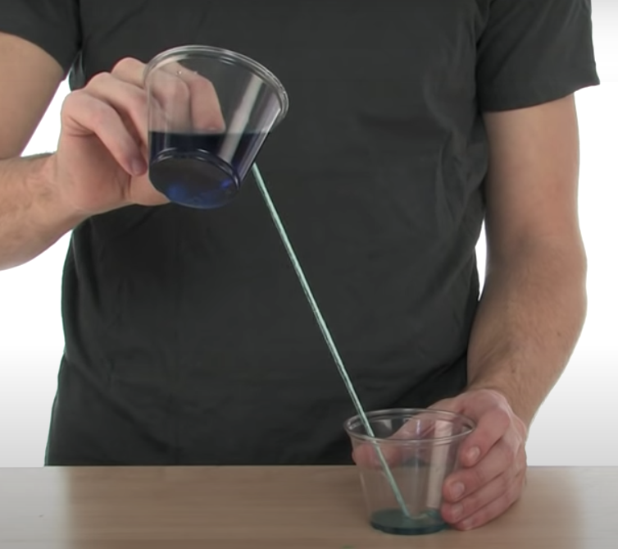

Wrap-up
- What did you learn in this experiment?
- If you were to repeat it, what would you do differently? Would you use the same materials?
- What surprised you? What did you observe that was the same as your expectations?

Lesson Background for Teachers

Suggested Real-World STEM Connections

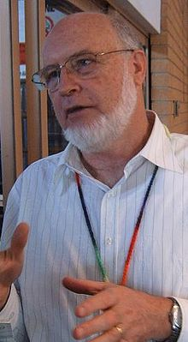
- Name: John Williams
- Years: current scientists
- Quick Facts:
  - Australian scientist who works on hydrology
  - Works to improve the use of water for agriculture
  - Studies how to best use water resources to help the environment and agriculture
  - Has provided technical advice to many government agencies on how to best and most sustainably use our water resources
- Source(s):
  - https://www.usgs.gov/staff-profiles/john-williams?qt-staff_profile_science_products=0#qt-staff_profile_science_products

Real-World Connections
- Fun real-world fact: this is how siphons work!
- Explanation: one end of a tube filled with liquid is higher than the other end. The liquid will flow upward temporarily, moving through the tube from a lower level to a higher level, before discharging at a lower level.

Lesson Variations and Options
- Try using a different liquid and see how the results change.
- Try using a different type of string and see how the results change or stay the same.
- Try using a different object than a string and try to transport the water with that.

Key Concepts and Vocabulary
- Concentration= the amount of a substance in a defined space
- Adhesion = attractive force between molecules of two different substances
  - Eg. water being absorbed by a paper towel or string
- Cohesion = attractive force between molecules of the same substance
  - Eg. water sticking to itself like a water droplet on a penny
- Gravity = the force that attracts an object towards the center of earth

Safety Notes
- Be careful not to get food coloring on anything it might stain, and wash your hands at the end of the experiment.
- Have extra paper towels available to clean up any spills.

Standards

NGSS PEs

Properties of liquids.

NGSS SEPs  Exploration of liquid properties and how liquids always seek their own level. | NGSS DCIs  Liquid properties and their effects. | NGSS CCCs  Cause and effect.  Chemistry.

